EX No:1b | EDA DATA CLEANING

AIM

To perform exploratory data analysis on the World Happiness Analysis dataset by examining the dataset structure, dimensions, data types, statistical characteristics, missing values, country-wise and region-wise attack distributions, attack types, correlations among numerical attributes, and exporting the dataset into different file formats.

ALGORITHM
- Import the required libraries such as kagglehub, os, and pandas.
- Download the World Happiness Database using KaggleHub.
- Identify the CSV file available in the downloaded dataset.
- Load the CSV file into a Pandas DataFrame using latin1 encoding.
- Display the first five and last five records.
- Display the dataset information, shape, column names, and data types.
- Generate descriptive statistical information for numerical attributes.
- Identify the number of missing values in each column.
- Find the top 10 countries based on the happiness level.
- Analyze the distribution of Happiness across different regions.
- Analyze the different types of people.
- Display the unique happiness types available in the dataset.
- Generate the correlation matrix for numerical attributes.
- Export the dataset into CSV, Excel, and JSON formats.
- Display a confirmation message after successful file creation.

CODE
import pandas as pd
import numpy as np

from sklearn.model_selection import train_test_split
from sklearn.preprocessing import LabelEncoder, StandardScaler
from sklearn.impute import SimpleImputer
from sklearn.ensemble import RandomForestClassifier
from sklearn.metrics import accuracy_score, classification_report, confusion_matrix
print("="*60)
print("BUSINESS UNDERSTANDING")
print("="*60)
print("""
Objective:
Predict whether a country's Happiness Level is
Low, Medium or High using socio-economic indicators.
""")

df = pd.read_csv("/content/world_happiness.csv") # Change filename if necessary

print("="*60)
print("DATA UNDERSTANDING")
print("="*60)

print("\nFirst 5 Rows")
print(df.head())

print("\nDataset Shape")
print(df.shape)

print("\nColumn Names")
print(df.columns)

print("\nDataset Information")
print(df.info())

print("\nMissing Values")
print(df.isnull().sum())

print("\nStatistical Summary")
print(df.describe(include='all'))

print("="*60)
print("DATA PREPARATION")
print("="*60)

# Remove duplicate rows
df = df.drop_duplicates()

# ------------------------------------------
# Find target column automatically
# ------------------------------------------

if "Happiness Score" in df.columns:
target = "Happiness Score"

elif "Ladder score" in df.columns:
target = "Ladder score"

elif "Life Ladder" in df.columns:
target = "Life Ladder"

else:
raise Exception("Happiness Score column not found.")

print("Target Column :", target)

df["Happiness_Level"] = pd.qcut(
df[target],
q=3,
labels=["Low","Medium","High"]
)

X = df.drop([target,"Happiness_Level"], axis=1)

y = df["Happiness_Level"]

print("\nEncoding Categorical Columns...")

label_encoders = {}

for column in X.columns:

if X[column].dtype == 'object':

le = LabelEncoder()

X[column] = le.fit_transform(X[column].astype(str))

label_encoders[column] = le

# Encode Target

target_encoder = LabelEncoder()

y = target_encoder.fit_transform(y)

print("Handling Missing Values...")

imputer = SimpleImputer(strategy="mean")

X = pd.DataFrame(
imputer.fit_transform(X),
columns=X.columns
)
print("Scaling Features...")

scaler = StandardScaler()

X = scaler.fit_transform(X)

print("="*60)
print("TRAIN TEST SPLIT")
print("="*60)

X_train, X_test, y_train, y_test = train_test_split(
X,
y,
test_size=0.20,
random_state=42
)

print("Training Samples :", len(X_train))
print("Testing Samples :", len(X_test))

print("="*60)
print("MODELING")
print("="*60)

model = RandomForestClassifier(
n_estimators=100,
random_state=42
)

model.fit(X_train, y_train)

print("Model Training Completed.")

y_pred = model.predict(X_test)

print("="*60)
print("EVALUATION")
print("="*60)

accuracy = accuracy_score(y_test, y_pred)

print("Accuracy :", round(accuracy*100,2), "%")

print("\nClassification Report")
print(classification_report(y_test,y_pred))

print("\nConfusion Matrix")
print(confusion_matrix(y_test,y_pred))

print("="*60)
print("FEATURE IMPORTANCE")
print("="*60)

importance = pd.DataFrame({
"Feature": df.drop([target,"Happiness_Level"], axis=1).columns,
"Importance": model.feature_importances_
})

importance = importance.sort_values(
by="Importance",
ascending=False
)

print(importance)
print("="*60)
print("DEPLOYMENT")
print("="*60)

sample = X_test[0].reshape(1,-1)

prediction = model.predict(sample)

result = target_encoder.inverse_transform(prediction)

print("Predicted Happiness Level :", result[0])

print("\nProject Completed Successfully.")

OUTPUT

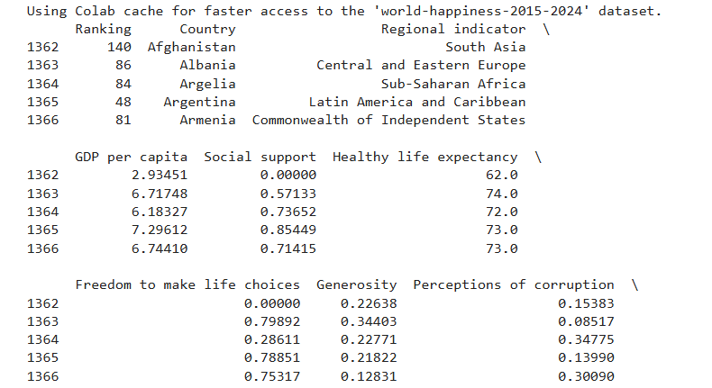

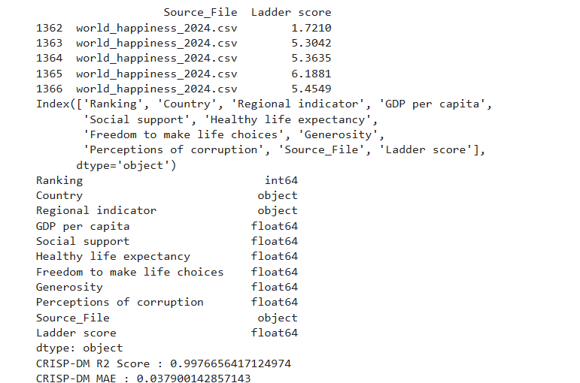

RESULT

